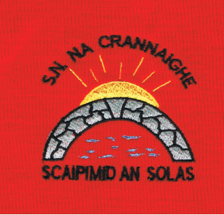
Cranny National School, Roll No. 13804O
Carrowreagh East,
Ennis,
Co. Clare.
(065) 6832345

Enrolment Application Form for SEPTEMBER 2023

CHILD
Child’s First Name: |  | Child’s Surname:
Sex: Male  Female | P.P.S. No: | Date of Birth: | Child’s Nationality:
Home Address: |  | Previous School/Playschool:
Medical & Allergy Information: |  | Doctors Name
Has your child attended any specialist i.e. Medical Consultant, Speech Therapist, Occupational Therapist etc. Yes No  Has he/she any Reports that are relevant to the school? Yes No |  | Is English the primary language spoken at home?  Yes No

PARENT/GUARDIANS
Mother/Guardian: | Father/Guardian:
Full Name: | Full Name
Mothers Nationality: | Fathers Nationality:
Address(if different from above) | Address(if different from above)
Home Telephone No. | Home Telephone No.
Mobile No. | Mobile No.
Work No. | Work No.
Email Address: (please print clearly) | Email Address: (please print clearly)

Parent/Guardian’s Signature; ______________________
Parent /Guardian’s Signature: ______________________

Date:___________________________

Date Received in Office:

