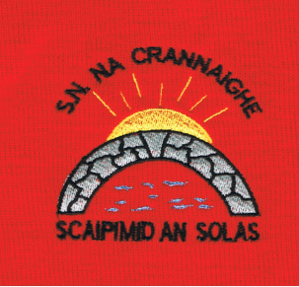
Cranny National School, Roll No. 13804O
Carrowreagh East,
Ennis,
Co. Clare.
(065) 6832345

Enrolment Registration Form for SEPT 2022

CHILD
Child’s First Name: |  | Child’s Surname:
Sex: Male  Female | P.P.S. No: | Date of Birth: | Child’s Nationality:
Home Address: |  | Previous School/Playschool:
Medical & Allergy Information: |  | Doctors Name
Has your child attended any specialist i.e. Medical Consultant, Speech Therapist, Occupational Therapist etc. Yes No  Has he/she any Reports that are relevant to the school? Yes No |  | Is English the primary language spoken at home?  Yes No

PARENT/GUARDIANS
Mother/Guardian: | Father/Guardian:
Full Name: | Full Name
Mothers Nationality: | Fathers Nationality:
Address(if different from above) | Address(if different from above)
Home Telephone No. | Home Telephone No.
Mobile No. | Mobile No.
Work No. | Work No.
Email Address: (please print clearly) | Email Address: (please print clearly)

OTHER CONTACT
Name: | Name
Relationship | Relationship
Mobile No. | Mobile No.

GENERAL CONSENTS FORM

 | YES | NO
I consent that my child may receive any necessary medical care from a doctor, ambulance crew, hospital etc. in the event of an accident or illness occurring where the school is unable to contact the parents/guardians.

I consent to my child going on supervised school outings such as sports events, Library, Swimming Pool, Parish Church etc.

I consent to the school submitting my child in group photographs, for use on the school website/local newspapers.

I consent to my child’s clothes being changed by school staff if they become soiled or wet.

I consent to in-school educational tests for my/our child e.g. Belfield, Mist, Drumcondra, Sigma-T.

I consent to Learning Support in English and/or Maths if my child meets the criteria for support.

I consent to my child taking part in the Stay Safe Programme.

I consent to my child taking part in the RSE (Relationship & Sexuality) Programme.

I consent my child’s name and address to be given to other agencies i.e. Parish, HSE (for Vaccinations, hearing and sight tests) etc.

I/We have read and understood the above consents. I/We wish to enrol my/our child in Cranny National School.

I/We undertake to see that my/our child will attend school punctually and regularly.
I/We confirm that I/We are aware that the data relation to this application will be kept in school files and may be used by School Management in the election of Parents/Guardians to the school Board of Management.

Parent/Guardian’s Signature; ______________________
Parent /Guardian’s Signature: ______________________

Date:___________________________

Date Received in Office:

